- Virtualization Vs Cloud

 | Virtualization | Cloud
Definition | Technology | Methodology
Purpose | Create multiple simulated environments from 1 physical hardware system | Pool and automate virtual resources for on-demand use
Use | Deliver packaged resources to specific users for a specific purpose | Deliver variable resources to groups of users for a variety of purposes
Configuration | Image-based | Template-based
Lifespan | Years (long-term) | Hours to months (short-term)
Cost | High capital expenditures (CAPEX), low operating expenses (OPEX) | Private cloud: High CAPEX, low OPEX  Public cloud: Low CAPEX, high OPEX
Scalability | Scale up | Scale out
Workload | Stateful | Stateless
Tenancy | Single tenant | Multiple tenants

- Virtual Machine Vs Container
Virtual Machine | Container
VM is piece of software that allows you to install other software inside of it so you basically control it virtually as opposed to installing the software directly on the computer. | While a container is a software that allows different functionalities of an application independently.
Applications running on VM system can run different OS. | While applications running in a container environment share a single OS.
VM virtualizes the computer system. | While containers virtualize the operating system only.
VM size is very large. | While the size of container is very light; i.e. a few megabytes.
VM takes minutes to run, due to large size. | While containers take a few seconds to run.
VM uses a lot of system memory. | While containers require very less memory.
VM is more secure. | While containers are less secure.
VM’s are useful when we require all of OS resources to run various applications. | While containers are useful when we are required to maximize the running applications using minimal servers.
Examples of VM are: KVM, Xen, VMware. | While examples of containers are: RancherOS, PhotonOS, Containers by Docker.

- IAAS Vs PAAS Vs SAAS

 | IAAS | PAAS | SAAS
Stands for | Infrastructure as a service. | Platform as a service. | Software as a service.
Uses | IAAS is used by network architects. | PAAS is used by developer. | SAAS is used by end user.
Access | IAAS give access to the resources like virtual machines and virtual storage. | PAAS give access to run time environment to deployment and development tools for application. | SAAS give access to the end user.
Model | It is service model that provide visualized computing resources over internet. | It is a cloud computing model that delivers tools that is used for development of application. | It is a service model in cloud computing that host software make available for client.
Technical understanding. | It required technical knowledge. | In which you required knowledge of subject to understand basic setup. | There is no requirement about technicalities company handle everything.
Popularity | It is popular between developer and researchers. | It popular between developer who focus on the development of apps and scripts. | It is popular between consumer and company. Such as file sharing, email and networking.
Cloud services. | Amazon web services, sun, vcloud express. | Facebook, and google search engine. | M.S office web, Facebook and google apps.
Enterprise services. | AWS virtual private cloud. | Microsoft azure. | IBM cloud analysis.
Outsourced cloud services. | Salesforced | Force.com, Gigaspaces. | AWS, terremark

- Details use of Roles & access cross account
An IAM role is an IAM identity that you can create in your account that has specific permissions.
An IAM role is similar to an IAM user, in that it is an AWS identity with permission policies that determine what the identity can and cannot do in AWS.
Use cases of Roles:-
- An IAM user in the same AWS account as the role
- An IAM user in a different AWS account than the role
- A web service offered by AWS such as amazon elastic compute cloud (EC2)
- An external user authenticated by an external identity provider service. that is compatible with SAML 2.0 or OpenID connect, or a custom-built identity broker.

- How many custom policies can attach to user, group and roles?
Default 10 managed can attached to user and role
10 managed policy to each group

- How many lines can add in single policy?
6144 character per managed policy
In line policy
User policy upto 2048 character
Role policy upto 10240 characters
Group policy upto 5120 characters

- Practical on cross account access using IAM role
- Can we use same ec2 role for ECS lambda?
No, we cannot use same EC2 role for ECS lambda
If I want to provide EC2 role to EC2 lambda then
Select role trusted Relationship add ECS policy for ECS lambda

- Trust Relationship
Trust relationship is permission which given to another account to access services.

- What is permission boundary?
Permission boundary is an advanced feature of using a managed to set the maximum permissions that identity-based policy can grant to an IAM policy.
An entity’s permissions boundary allows it to perform only the actions that are allowed by both its identity-based policies and its permission boundaries.
If group has Administration access in that you want to give only specific permission to specific user of group like s3fullAccess to user1 then permission boundary use. The user can’t access other services except s3.

- Realtime use of Identity Provider
With an identity provider (IdP), you can manage your user identities outside of AWS and give these external user identities permissions to use AWS resources in your account.

- IAM access type
- Programmatic access
- Console access

- What is root user?
root user is email id account

- Access key secrete key can create
2 access keys can attach to user

- How Realtime you use IAM user?
Policy group user

- Types of policy
  - Customed policy – is user created policy
  - AWS managed policy – is AWS created policy
  - Inline policy – assign on role

- Types of policy in AWS
- Identity-Based policy -- Identity-based policies are JSON permissions policy documents that control what actions an identity (users, groups of users, and roles) can perform, on which resources, and under what conditions.
  - Managed Policy -- Standalone identity-based policies that you can attach to multiple users, groups, and roles in your AWS account.
    - Aws managed policy -- Managed policies that are created and managed by AWS.
    - Customer managed policy -- Managed policies that you create and manage in your AWS account.
  - Inline policy -- Policies that you add directly to a single user, group, or role. They are deleted when you delete the identity.
- Resource Based Policy -- Resource-based policies are JSON policy documents that you attach to a resource such as an Amazon S3 bucket.
- Permission Boundary -- A permissions boundary is an advanced feature in which you set the maximum permissions that an identity-based policy can grant to an IAM entity.
- Organizations SCP’s --
- Access Control Lists (ACL’s) -- Access control lists (ACLs) are service policies that allow you to control which principals in another account can access a resource.
- Session Policies -- Session policies are advanced policies that you pass as a parameter when you programmatically create a temporary session for a role or federated user.

- TASK IAM has programmatic access that user should create EC2 instance in another account using cli

- Assume role in IAM, benefit and how to setup?

Set of temporary credentials that you can give access aws resources

- Which services use to store data in AWS?
EBS EFS and S3

- What is S3?
Amazon S3 or Amazon Simple Storage Service is a service offered by Amazon Web Services that provide object storage through a web service interface.

- Benefit of S3
- Reliable Security
- All time Availability
- Very low cost
- Ease of migration
- The simplicity of management

- S3 lifecycle
s3 lifecycle is process that can automatically transfer unused object to another class to reduce price
s3 lifecycle flow
s3 storage (30 days) s3 standard infrequent access (next 30 days) s3 glacier instance (next 30 days) s3 glacier deep archive

- S3 storage classes
- S3 standard storage for frequently accessed data
- S3 Intelligent tiering for automatic cost savings for data with unknown or changing access patterns
- S3 Infrequent Access for less frequently accessed data
- S3 one zone Infrequent Access for less frequently accessed data within single AZ
- S3 Glacier Instant Retrieval for archive data that needs immediate access
- S3 Glacier Flexible Retrieval for rarely accessed long-term data that does not require immediate access
- S3 Glacier Deep Achieve for long-term archive and digital preservation with retrieval in hours at the lowest cost storage in the cloud

- How many EC2 instance run in your environment?
20 instances can run in your environment

- Types of AMI
- Instance Store – backed instance
- EBS – Backed instance
- What is tenancy? Different types and differences
Tenancy defines how EC2 instances are distributed across physical hardware and affects pricing.
There are 3 types of tenancy:
- Shared (defaults) – multiple AWS accounts may share the same physical hardware
- Dedicated Instance (dedicated) – your instance runs on a single-tenant hardware
- Dedicated Host (Host) – Your instance runs on a physical server with EC2 instance capacity fully dedicated to your use, an isolated server with configurations that you can control.

- TASK attach multiple Security Groups to Running instances
EC2 Select instance Actions Security change security groups assign security groups

By defaults you can attached 5 security groups which is depend upon network interface

- What is use of User Data?
AWS userdata is the set of commands/data you can provide to a instance at launch time

- What is base64 encoded in user data?
Base64 encoded is used to transfer data from binary form (0,1) to ASCII character (human readable) or v.v.

- What is kernel id?
- What is RAM id?
- Instance type
- General purpose
- Compute optimized
- Memory optimized
- Storage optimized
- Accelerated computing (GPU)

- Instance type’s example?
- General purpose
- T, M, A
- Developing, testing, virtual desktop
- Compute optimized
- C
- Gaming, video encoding, batch processing
- Memory optimized
- R, X
- Real time big data analytics
- Storage optimized
- I, D
- Relational Databases, NoSQL databases
- Accelerated computing
- P, G,
- Machine learning, autonomous vehicles

- Purchasing options
- on demand
- spot instance
- reserved instance
- saving plans
- dedicated host
- dedicated instance
- capacity reservations

- What is Spot instance? Example
A spot instance is an instance that uses spare EC2 capacity that is available for less than the on-demand price. Because spot instance enables you to request unused EC2 instance at steep discounts, you can lower your amazon EC2 costs significantly. The hourly price for a spot instance is called a spot price.
Ex. For testing, Development

- Realtime Manage spot instance
- What is status check? How to resolve it?
Instance status checks monitor the software and network configuration of your individual instance
There are 3 types of status check:
- 0/2 – show hardware related issue
- For resolve, contact AWS support
- 1/2 – show software related issue
- Check log and mail and resolve it
- 2/2 – hardware and software are all ok

- Why 1/2 issue occurs?
- Booting process has not properly boot that time ½ issue occurred

- TASK ½ issue in fstab, kernel, GRUB one solution.
- Create new instance of same configuration
- Detach volume of first instance and attached to new instance
- Crate directory
- Mount volume (old instance) on new instance (created directory)
- Copy boot directory to created directory
- Umount directory
- Detach old volume and attached to old instance

- How to resolve ssh key lost?
- Create new instance of same configuration with different key
- Detach volume of first instance and attached to new instance
- Crate directory /var/recover
- Mount volume (old instance) on new instance (created directory)
- Copy /home/ec2-user/.ssh/authorized_keys /var/recover/home/ec2-user/.ssh/authorized_keys
- umount directory /var/recover
- Detach old volume and attached to old instance
- Connect instance with new instance key

- Launch template Vs launch configuration
Launch Configuration | Launch Templates
It defines the configuration of EC2 instance | Similar to LC
AMI, Instance type, Security group, Device Block and Key pair can configure | Include all features that’s the part of LC
Can define Userdata and IAM Role
One LC to One Autoscaling Group | Can modify In ASG
LC is not editable – create new always | In LT we can create multiple version

- AMI Vs Snapshot
AMI | Snapshot
AMI are associate with EC2 instance | Snapshot are associate with EBS
AMIs are bootable copy of the whole instance | Snapshots are the backup of the data on EBS volumes
AMIs are used to store the current instance configuration | Snapshot is simply a backup of the disk drive

- Relation between AMI and Snapshot
- EBS Vs Instance Store
EBS | Instance Store
EBS volume is network attached drive which results in slow performance but data is persistent meaning even if you reboot the instance data will be there. | Instance store provides temporary block-level storage for your instance. This storage is located on disks that are physically attached to the host computer.

- Why AMI create fast as compared to VM box?
- What is AMI?
AMI is a master image for the creation of virtual servers known as EC2 instances.
Each AMI includes a template for the root volume required for a particular type of instance.

- How to create AMI?
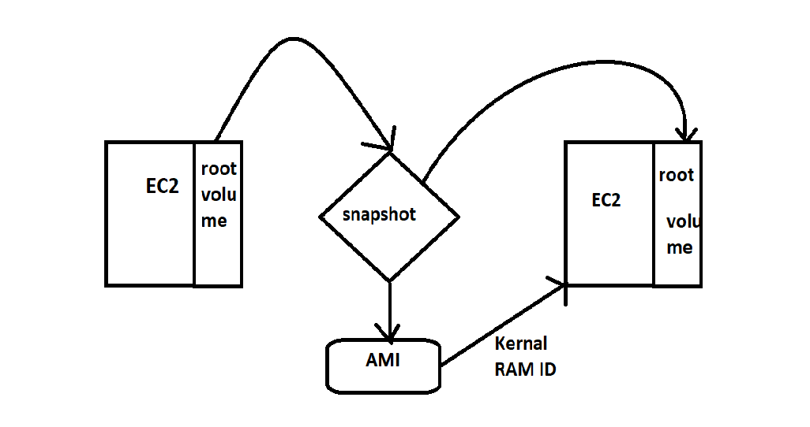

- How to see/create application log on CloudWatch?
- Types of Regions and datacenter?
- Types of EBS volumes and explain it
  - Solid State Drive (SSD)
        - General Purpose SSD (gp2, gp3)
        - Provisioned IOPS SSD
  - Hard Disk Drive (HDD)
        - Throughput Optimized HDD
        - Cold HDD
  - Previous Generation
        - magnetic

- EBS Vs EFS Vs S3
EBS:-
- high performance, per instance block storage.
- EBS used to be accessible to a single EC2 instance only.
- Making it most like your physical hard drive.
- Generally, it used as per instance storage but in special cases, amazon EBS multi-attach can turn EBS into multi-instance storage like EFS.
- EBS is a block storage service, which means all data within EBS is stored in equally sized blocks.
EFS:-
- EFS can be mounted by multiple EC2 instances
- Meaning many virtual may store files within an EFS instance.
- Main feature is its scalability.
- EFS can grow or shrink according to demands.
- More and more files being added without disturbing your application or having to provision new infrastructure.
S3:-
- S3 is a scalable.
- It can also be accessed by other cloud service, and its object storage system makes it ideal for handling large volumes of static data as well as complex queries.
- Highly available
- Flexible
- Data archiving.

- Realtime use of EBS volume
- Security Group vs NACL

Security Group | NACL
Assign on instance | Assign on subnet
Security group can be understood as a firewall to protect EC2 instances | NACL can be understood as a firewall or protection for subnet
Security groups are associated with an instance of a service. It can be associated with one or more security groups which has been created by the user | Multiple subnets can be bound with a single NACL, but one subnet can be bound with a single NACL only, at a time
These are stateful, which means any changes which are applied to an incoming rule is automatically applied to a rule which is outgoing. | These are stateless, meaning any change applied to an incoming rule isn’t automatically applied to an outgoing rule
It supports only allow rules, and by default, all the rules are denied. You cannot deny the rule for establishing a connection. | It supports both allow and deny rules, and by default, all the rules are denied. You need to add the rule which you can either allow or deny it.
It is the first layer of defense. | It is the second layer of defense.

- Difference between Global, Region and Availability Zone specific
- TASK move data from one AZ to another AZ using snapshot
- How many Security group can create in single vpc?
500

- What is Elastic IP?
An Elastic IP address is a static IPv4 address designed for dynamic cloud computing.

- What is placement group?
Placement Groups let you to choose the logical placement of your instances to optimize for communication, performance or durability.
You can create a maximum of 500 placement groups per account in each Region.
The name that you specify for a placement group must be unique within your AWS account for the Region.

- Types of placement group?
- Cluster – Single availability zone in that single hardware in that multiple instance
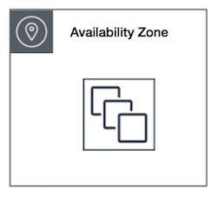
- Partition – Single availability zone in that multiple hardware and each hardware consist multiple instances
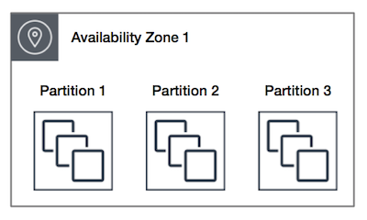
- Spread -- Single availability zone in that multiple hardware and each hardware consist single instance
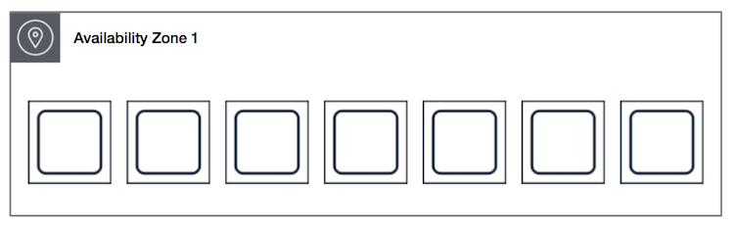

- Use of placement group

- What is Network Interface? Use?
- How many private IP can assign to instance?
It depends upon the instance type of instance

- How many Security Group can allocated to Instance?
By defaults you can attached 5 security groups which is depend upon network interface

- How many NACL attached to single vpc?
1 NACL per subnet

- Difference types of Load Balancer
There are 4 types load balancer
- Classis Load Balancer
- Application Load Balancer
- Network Load Balancer
- Gateway Load Balancer

- Realtime use of application and Network Load Balancer
- Application Vs Network Load Balancer

- Use of target group
A target group tells a load balancer where to direct traffic to EC2 instances, fixed IP addresses; or AWS Lambda functions, amongst others.
- Types of Target Group
- Instance
- Lambda
- IP
- Application load balancer

- Explain Autoscaling
AWS Auto Scaling monitors your applications and automatically adjusts capacity to maintain steady, predictable performance at the lowest possible cost.

- Types of autoscaling
- Static
- Dynamic
- Scheduling

- Types of autoscaling policy
  - Target tracking scaling
  - Step scaling
  - Simple scaling

- EC2 vs ElasticBenstock

